Geometry

Shapes, Measurement, and Symmetry

Grades 2-3

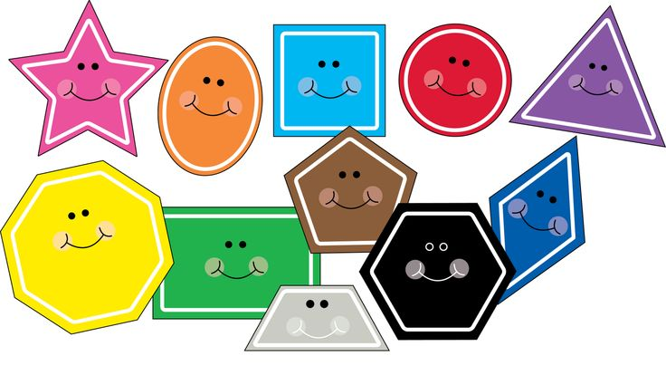

Leighann Mensen, Central Elementary, leighann_mensen@isd31.net
Kara Foehrenbacher, Northern Elementary, kara_foehrenbacher@isd31.net
Angie Bonik, Northern Elementary, angela_bonik@isd31.net
Executive Summary

This unit is designed to build geometry and measurement concepts. Through games and activities students will practice different strategies to solve geometric problems involving shapes and measurement. In each lesson, they will align with the Minnesota K-12 Academic Standards under Geometry and Measurement in second and third grade.

MN State Standards:
2.3.2.2 Demonstrate an understanding of the relationship between length and the numbers on a ruler by using a ruler to measure lengths to the nearest centimeter or inch.

2.3.1.2 Identify the name of basic two- and three- dimensional shapes, such as squares, circles, triangles, rectangles, trapezoids, hexagons, cubes, rectangular prisms, cones, cylinders, and spheres.

3.3.2.1 Use half units when measuring distances.

3.3.1.2 Sketch polygons with a given number of sides or vertices (corners), such as pentagons, hexagons and octagons.

2.3.1.1Describe, compare, and classify two- and three-dimensional figures according to number and shape of faces, and the number of sides, edges and vertices (corners).

3.3.1.1 Identify parallel and perpendicular lines in various contexts, and use them to describe and create geometric shapes, such as right triangles, rectangles, parallelograms and trapezoids.

MCA Test Sample Questions

8. Two lines are shown.
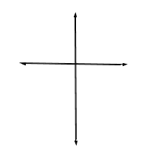
8. Which describes the relationship between the lines?
A. Parallel
B. Perpendicular
C. Square
D. Straight

18. Which shape has the fewest angles?
- Hexagon
- Octagon
- Pentagon
- Trapezoid

19. The perimeter of a rectangle is 16 inches. Its length is 5 inches. What is its width?
- 3 inches
- 6 inches
- 11 inches
- 21 inches

Table Of Contents

1. Measure Stick
2. Measuring Paths
3. Flying with Paper
4. Measure and Create
5. Measurement Olympics
6. Measurement Olympics Cont’d
7. Shape Sort
8. Build the Shapes
9. Shape Pictures
10. Pattern Block Tiling
11. Shape Shifting-The Greedy Triangle
12. Quadrilateral Sort
13. Quadrilateral Search
14. Scoot: Parallel and Perpendicular Lines
15. 3-D Shape Search

Pre-test/Post-Test NAME_______________________

- Measure to the nearest inch  ______________ inches | 2. Measure to the nearest centimeter  _____________ cm
3.  How many sides?________  How many vertices?_______  Name the shape__________________ | 4.  How many sides?________  How many vertices?_______  Name the shape__________________
5. What are 2 things that are the same about these shapes?  - __________________________  - __________________________ | 6. What are 2 things that are the different about these shapes?  - __________________________  2. __________________________

Measure Stick
Standard:
2.3.2.2 Demonstrate an understanding of the relationship between length and the numbers on a ruler by using a ruler to measure lengths to the nearest centimeter or inch.

Objective:
Students will construct an inch stick and use it to measure objects in the classroom.
Students will compare the inch stick to a ruler and show the similarities between them.
Materials:
- notebooks
- pencils
- rulers
- objects to measure
- pre-measured and cut strips of paper (one foot ruler sized)

Launch:
My husband and mother-in-law own a bakery and I helped make a special birthday cake for a customer. Show students a cake box and tell them that I need to know how big the box is to see if my cake will fit inside the box. How can I figure out if my cake will fit in the box if my cake is 13 inches wide and 18 inches long? Have students pair and share with someone next to them to share ideas of how they could figure it out. Explain that you lost your ruler and there aren’t anymore around to use to measure the box. Tell students that today they will be making their own inch sticks to measure the box and other items in the room.

Explore:
Have students take out a notebook and pencil and have them make sure the notebook has the wide space on top and the spirals on the left before they start. Pass out the strips of paper. Ask students to fold the strip in half the hamburger way. Starting on the first blue line where the red margin line meets(meaning writing over the line) have students write a 0. On the next blue line where the red margin line meets have students write a 1 and so on until you have lines marked 0-6. Now place the folded strip with the folded end touching where the lines cross at 0 and the open end on the 6 line. Then mark the folded paper at each numbered line 1-5 where it meets the paper. Make sure to demonstrate this. Flip the folded paper over and do the same thing on the back. Open it up and you have an inch stick. Pair students up and have them use their inch sticks to measure a large paper clip, their desktop, and any other object you would like. Ask students to record their measurements. Give each pair a turn to measure the cake box also while others are measuring other items around the room.

Share:
After all pairs have measured the cake box have students stop and discuss their measurements. Compare with other pairs. Did you get the same measurements? Then ask if the class can tell you if the cake will fit in the box or not.
Summarize:
Have students compare their inch sticks to a ruler to see the similarities. Ask students why the inch stick might be easier to measure with than a ruler when you don’t have to be precise. Thank students for helping you to decide whether or not the cake would fit in the box.

Assess/Analyze:
Have students use the inch stick they made to measure an unsharpened number 2 pencil that you have given them and collect their answers on an exit slip.

Measuring Paths
Launch:
Have you ever thought about which lines are actually the shortest? We will be examining three different lines: straight, curves, and zig zaged. Using our rulers, we will measure to determine which of the three lines is actually shorter and why. The MN Standard covered in this activity is 2.3.2.2 and 3.3.2.1.

Explore:
Students will be given three different examples each containing three different paths. They will have to predict which path is the shortest and why they believe so, and then measure all three lines to determine which path is actually the shortest. Measurement will be done in inches using a ruler.

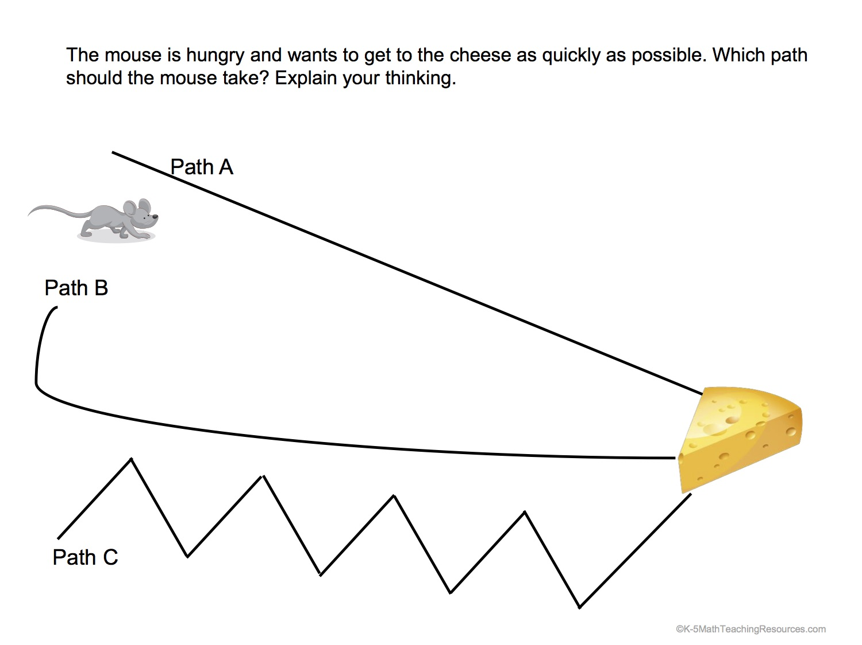

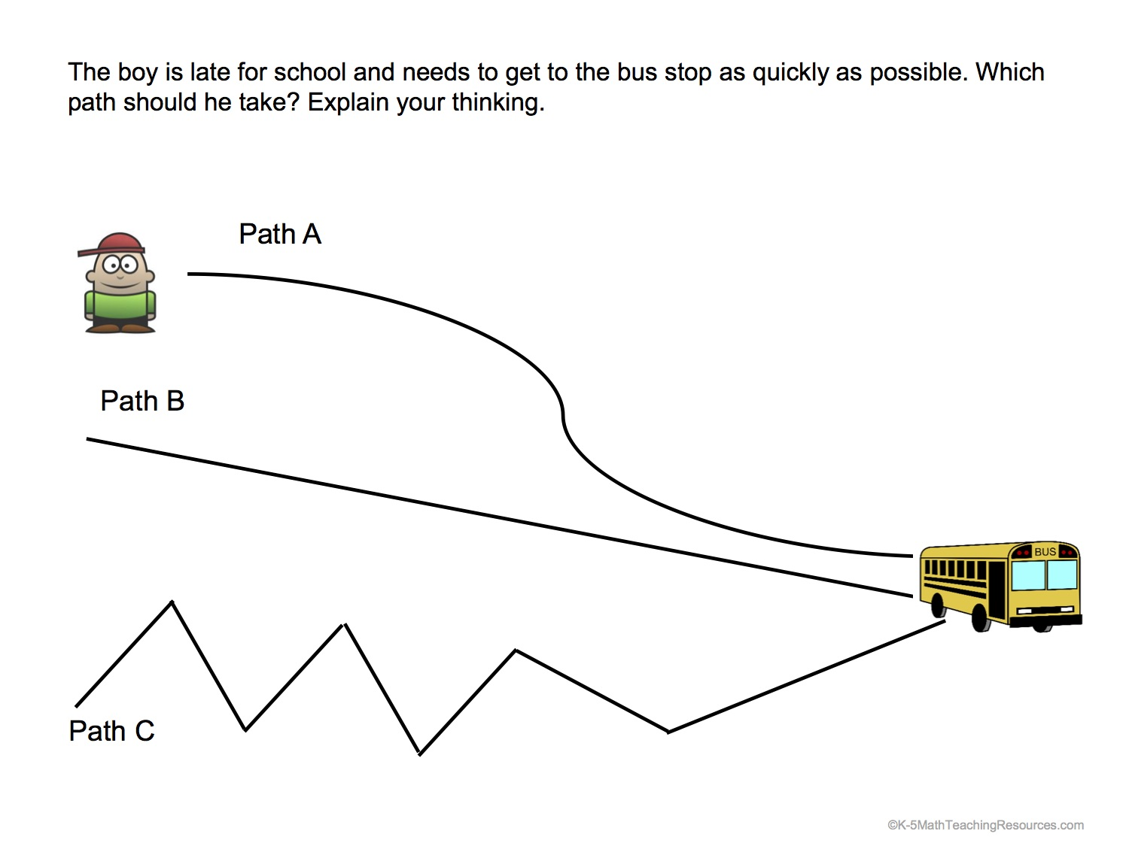

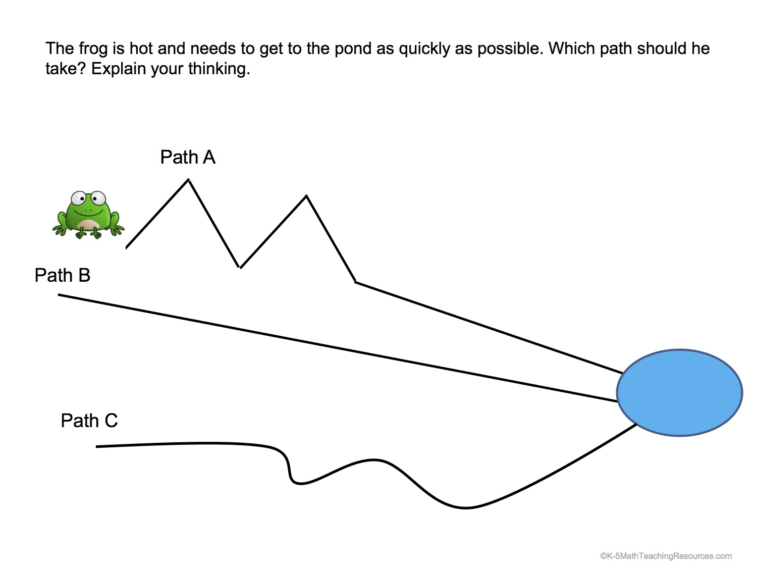
Share:
Students will share their results with each other and compare the lengths they got for each line. Questions such as: Did you find that the same line was the shortest for all three problems? Why or why not? How did you measure the curved line? How did you measure the zig zagged line?

Summarize:
Today’s lesson had students making predictions, using rulers to measure to the nearest inch and half inch, and problem solving.

Flying with Paper

Launch:
Normally, paper airplanes are not allowed in school. However, the airport is open in our classroom and hallway just for today! During today’s lesson, we will be flying paper airplanes to see who can make theirs go the farthest. Students will make the “classic” paper airplane and be able to alter them after each flight if chosen. Students will have prior lessons regarding measurement in inches and to the nearest ½ inch. Our 5th graders will be coming in to help student fold their airplanes and give any tips if needed. The MN Standards addressed in this activity are 2.3.2.2 and 3.3.2.1.

Explore:
After their airplanes are folded, students will then get into pairs and fly against one another in the classroom or hallway. After each flight, students will have to measure the distance traveled in inches. After each flight, students have the ability to alter their airplanes for a longer distance if desired. Each student will conduct 10 flights and record each result on the recording sheet. The student with the longest flight will be the winner.
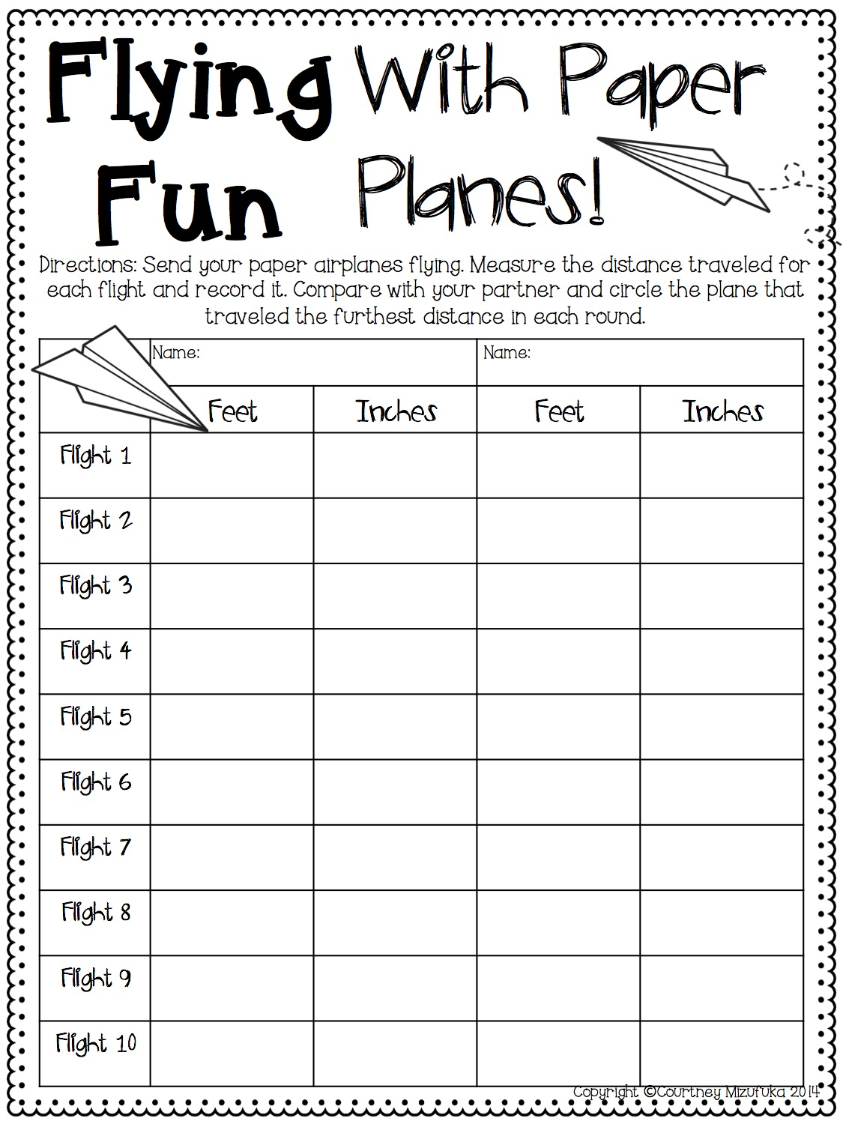

Share:
Results will be examined within each partner group and with the class as a whole. Questions such as: How did you and your partner measure the distance traveled if it went farther than 12 inches? What alterations did you make to have your airplane travel farther? What was the shortest distance recorded? What was the longest distance recorded?

Summarize:
The main idea of this lesson was to give students practice in measuring distances in inches, to the nearest ½ inch, and measuring with a ruler. Students had to problem solve with each other how to accurately measure a distance that was longer than their ruler and determine ways to improve their airplane’s distance.

Mizufuka, C. (2014). Flying With Paper Fun Planes! Retrieved June 26, 2017 from www.teacherspayteachers.com

Measure and Create

Launch:
Start out by asking students if they have an iPad or tablet at home. What kind of apps do they have on their iPad or tablet. Are all iPads or tablets the same size? Today we will be creating our own iPad using given measurements. It is very important that the directions are followed in order for your iPad to work. Students will be using centimeters only for this activity so prior knowledge of using a centimeter ruler and identifying lengths is important. The MN Standards covered in this lesson are 3.3.2.1 and 2.3.2.2.

Explore:
Students will get to choose one piece of colored construction paper. The teacher will give the iPad direction sheet out, but will also go through each of the directions with the students while they follow along. The first step, is for students to draw the perimeter of the iPad which is 12cm tall and 10cm wide. Then explain that there are 9 apps total on their iPad. Each app has 4 equal sides and each side is 2cm long. (At this point, you may have to show an example of what this will look like and how to draw these out). After the apps are drawn, have students name their apps. They will need to draw a power button at the bottom of their screen and after this is done, cut and glue this to the iPad worksheet. From there, students will need to draw a pen that is 10cm tall on the left of the iPad. After all directions are followed, students may play their favorite game on their iPad.

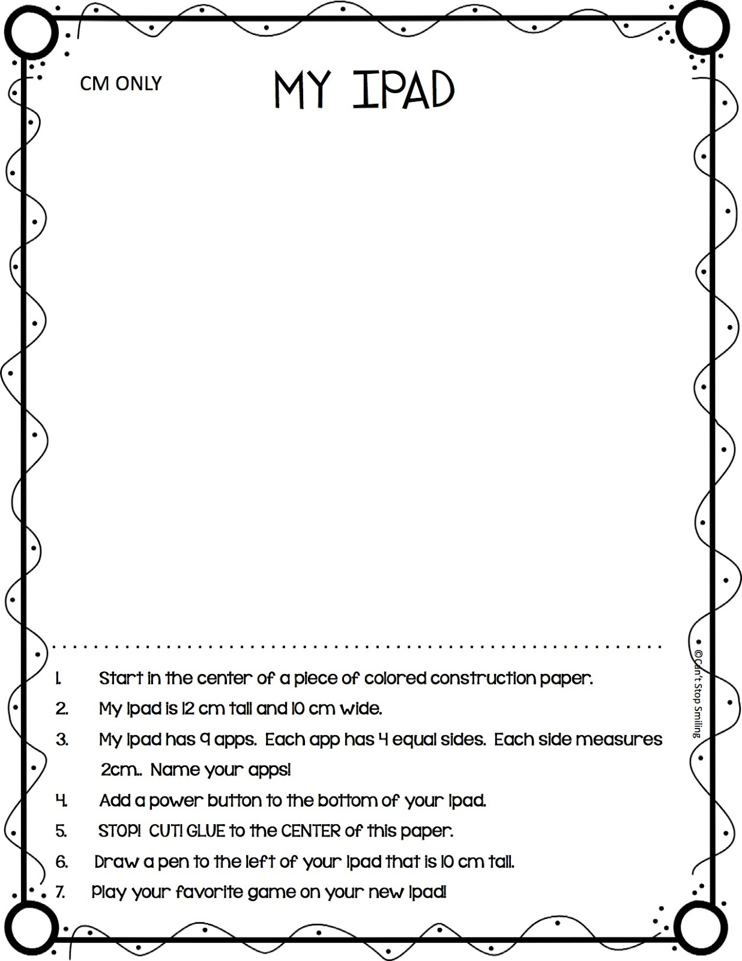

Share:
Students will be able to share and compare their iPads with others in the classroom. Although they may have different apps and their iPads are different colors, the measurements should be the same. This is a great time for students to double check their work.

Summarize:
The main idea of Measure and Create was to give students the opportunity to practice measurement in centimeters and following directions. Before the activity, students knew what their drawing would look like, just not the dimensions. This activity could be modified into different units of measurement and drawing of different objects.

Can’t Stop Smiling (2015). Measure and Create: iPad. Retrieved June 26, 2017 from www.teacherspayteachers.com

Measurement Olympics

Standard:
3.3.2.1 Use half units when measuring distances.

Objective:
Students will use meter sticks, measuring tapes, and rulers to measure distances to the nearest half inch and half centimeter.
Materials:
-2 or 3 paper plates
-3 or 4 plastic drinking straws
-2 bags of marbles
-3 meter sticks and meter tapes
-cotton balls
-large sponge
-large bowl or bucket
-liter measuring set
-centimeter graph paper
-balance scale with weights
-student worksheets

Launch:
Has anyone heard of the Olympics? Have any of you ever wanted to participate in the Olympics? We are going to be having our very own Olympics and each of you is going to be able to participate in at least one event. We have several events for you to compete in and you will be competing in teams. Just like the U.S. is a team, China is a team, etc. in the real Olympics. The events that you will compete in are the Paper Plate Discus, the Plastic Straw Javelin, the Cotton Ball Shot Put, the Right Handed Marble Grab, the Left Handed Sponge Squeeze, and the Big Foot Contest. Explain that the instructions for each event will be posted by the event station when students are competing in case they forget what to do. Show examples of each event and explain what needs to be done for each one carefully. Show where each event is located and explain where to go after each station. Go through the rules with the class.

Explore:
Divide students into teams of five and have them come up with a team name. There should be one captain on each team to read directions at each event and make sure all team members have their estimate BEFORE they start the event. When teams are ready with their names and captains have them begin at designated stations and make sure to tell them when to switch. Each member of each team should be completing the event and recording their own data. Students should get through three of the six stations today and finish the last 3 tomorrow.
Share:
After every team finishes their stations for the day ask students to share some of their experiences with the rest of the class for each event, but make sure they don’t share their estimations or data. They can share which events they found were easier or more challenging to estimate. Have them explain why they think it is easier or more challenging to estimate some rather than others. Were there any difficulties in measuring length, volume, mass, or area?
Summarize:
Today we had lots of fun with our Measurement Olympics and tomorrow we will continue so that everyone has had a chance to compete in all six events. We will be taking a look at the data and finding out who our winners are for each event and the overall team winner!
Assess/Analyze:
Collect student record sheets and look at the estimations and their calculations for the scoring to check for understanding.

Source: AIMS Education Foundation 1987, Math + Science: A Solution

Measurement Olympics Cont’d

Standard:
3.3.2.1 Use half units when measuring distances.

Objective:
Students will use meter sticks, measuring tapes, and rulers to measure distances to the nearest half inch and half centimeter.
Materials:
-2 or 3 paper plates
-3 or 4 plastic drinking straws
-2 bags of marbles
-3 meter sticks and meter tapes
-cotton balls
-large sponge
-large bowl or bucket
-liter measuring set
-centimeter graph paper
-balance scale with weights
-student worksheets

Launch:
Yesterday we started our very own Measurement Olympics here in our classroom and today we will be continuing with competing in events. Remember the rules and remember to record your estimate first and then record the actual measurements after completing the event. Good luck and have fun!

Explore:
Have teams begin where they left off and continue to rotate in the stations until everyone has completed all six events. When most have completed stop the students for a few minutes to explain and show how they will calculate their scores. Students should find the difference between each of their estimates and the actual data. Then add the differences together to find their total score. Explain that the LOWEST score is the winner. The lower your score the more accurate you were with your estimates. Have the students come and tell you their scores when they are finished. Record these on a spreadsheet.
Share:
When all students have finished show them the spreadsheet and announce the winners for each event and the overall team winner. Have teams share if they had any strategies that they used for any events regarding the estimation or the technique. Give medals or some sort of award to winners if you wish.
Summarize:
Tell students that they will be using the measurement skills they practiced in the Measurement Olympics to solve real world problems in the future. Explain that the metric units of length, volume, mass, and area are very useful to know in real world situations. Most other countries around the world use metric units of measurement and the metric system is commonly seen in the U.S. in places such as on a soda bottles, certain tools, and baking ingredients.
Assess/Analyze:
Collect student record sheets and look at the estimations and their calculations for the scoring to check for understanding.

Source: AIMS Education Foundation 1987, Math + Science: A Solution

Shape Sort
MN State Standard | Materials
2.3.1.2 Identify the name of basic two- and three- dimensional shapes, such as squares, circles, triangles, rectangles, trapezoids, hexagons, cubes, rectangular prisms, cones, cylinders, and spheres. | *Shape sheet for each group  *Scissors  *Math Journal or other recording sheet for students  *Chart paper & markers
Objective: The students will sort the shapes based on attributes and give each shape a name.

Launch: Today you will have to help me with a problem. I have all of these shapes and I need to find a way to organize them and name them all. Do you think you can help me with that task?

Explore: Students work in groups to cut out the shapes and sort them into an order that makes sense to them. The discuss how they will share their sort with the class.

Share: As a class listen and talk about how each group sorted their shapes. Is there a way we can start to name these shapes? Do we see a pattern between the number of sides and the number of corners or vertices?

Summarize: I like how we have organized our shapes. We do have a special name for each of these shapes and as we have discovered the big difference between them is the number of sides. This is how mathematicians name shapes.

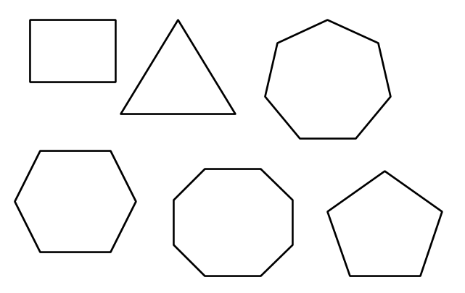

Build the Shapes
MN State Standard | Materials
2.3.1.2 Identify the name of basic two- and three- dimensional shapes, such as squares, circles, triangles, rectangles, trapezoids, hexagons, cubes, rectangular prisms, cones, cylinders, and spheres. | *Straws  *Pipe cleaner pieces cut to about 4’  *Scissors  *Math Journal or other recording sheet for students  *Anchor chart with shape names  *Chart paper & markers
Objective: The students will construct the 2D shapes that are on the class poster using straws and pipe-cleaner pieces.

Launch: Today you get to build the shapes we have been learning about. You will have some learning tools to work with and a group of mathematicians to work with. Your goal is to see how many shapes you can build.

Explore: Students work in groups to build the different shapes using the materials given.

Share: Groups share theirs shapes and as a class we can sort the shapes talking about congruent and similar. Students should use the terms sides and vertices when describing their shapes.

Summarize: Today we really explored a lot about shapes. We talked like mathematicians when we were working to build our shapes and when we shared our learning. We will leave our shapes up on the table so that we can keep thinking about how they are the same and different.

Shape Pictures

Launch:
How many different pictures do you think you can create using pattern blocks? Using the space on the left side of the paper, you will come up with an interesting picture using your pattern blocks. From this, you will be able to count the sides, angles, and total blocks used.

Explore:
In small groups or individually, students will create a picture using pattern blocks. After they have created a picture, they will trace each pattern block used so that when they remove the blocks, a tracing of their picture is left. Students will then graph what shapes they used using a bar graph. Students will also record the number of sides and angles their shape picture has along with the total shapes used.

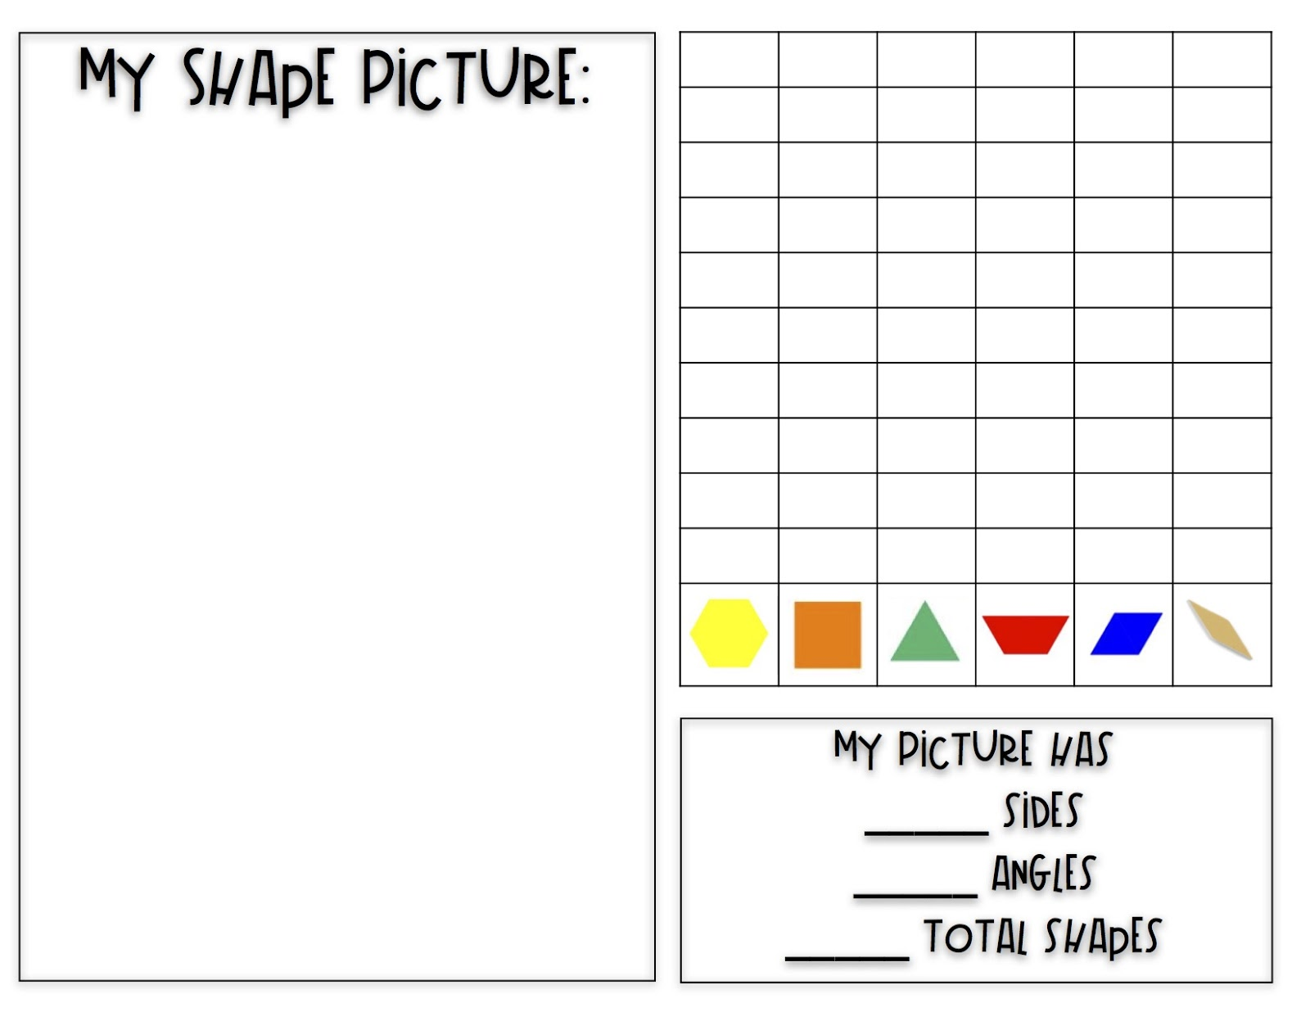
Share:
Students will post their shape pictures up around the room and students will do a gallery walk around the room to view. Students will then find the shape picture that has the most and least: sides, angles, and shapes used. We will examine pictures that used the same number of blocks, but had varying amounts of sides and angles to determine the difference between them.

Summarize:
The goal of this lesson was to get students familiar with pattern blocks, creating shapes with them, and being able to sketch their picture. Students are also required to count the total number of sides and angles, as well as graph their results.

The Teacher Creature (n.d.). Pattern Block Shape Picture. Retrieved June 26, 2017 from www.teacherspayteachers.com

Pattern Block Tiling

Standard:
3.3.1.2 Sketch polygons with a given number of sides or vertices (corners), such as pentagons, hexagons and octagons.

Objective:
Students will sketch polygons using pattern blocks as a guide to create a tiling.
Materials:
- pieces of printer paper
- pattern blocks
- pencils
- colored pencils

Launch:
Have a tiling pattern picture on the board (preferably one from around the school somewhere). Ask students what they think the picture is. Have students discuss what shapes and patterns they see in the picture with their pair and share partner. Explain that today they will have a chance to work with some shapes and patterns of their own. Tell students that you have a challenge for them. Their challenge is to completely fill a piece of printer paper with pattern block shapes with no spaces or gaps.

Explore:
Divide students into groups of three. Give students pattern blocks and a piece of printer paper. Have students work together in their groups to see is they can fill the paper with the shapes. As students are working go around and ask groups what different pattern block shapes are called and what attributes they have. After students have worked for a few minutes stop them and ask them to start tracing their pattern blocks on their paper with a pencil in case they move or they have to move them to other areas of the paper because they run out of that certain shape block. Ask if any groups have figured out which shapes they are going to use to cover the paper. Allow to work for several more minutes while asking questions about what they are finding as you go around to different groups.
Share:
When a group thinks they have figured it out or you have groups that are close, have them share their tilings on the visualizer. Ask questions about what shapes they found worked best together and which one didn’t. Ask why students think that is. Discuss the numbers of sides that each polygon has and get students to see the groups of polygons at a vertex. Have groups share which combinations of blocks they tried, but didn’t work and which ones they tried that did work.
Summarize:
Explain that covering a plane with regular polygons is called tiling and they can see examples of it everywhere. There are only certain regular polygons that work together to tile a plane. If groups were not finished working they may finish tomorrow.
Assess/Analyze:
Give students a pattern of blocks on the board and ask them to write if the pattern will tile a plane or not and explain why. Have students write their answers on an exit slip.

Shape Shifting- The Greedy Triangle
Launch:
Begin by asking students what they know about triangles? How many sides, angles, and vertices does it have? Quickly review the story The Greedy Triangle that was read yesterday and explain that student will hear it again today. Today’s lesson covers MN Standard 2.3.1.1.

Explore:
Whole Group
Students will be sitting at the rug for this activity with geoboards, rubber bands, and their recording sheet. While the teacher reads aloud The Greedy Triangle, students will create the shapes the triangle starts out at and shape shifts into on the geoboard. During this activity, students will record the name of the shape, the number of sides, angles, and vertices, and draw an example of that shape. As the triangle shape shifts into other shapes, students will first create it on their geoboard, and then fill in their recording sheet. This will continue until the story is done.

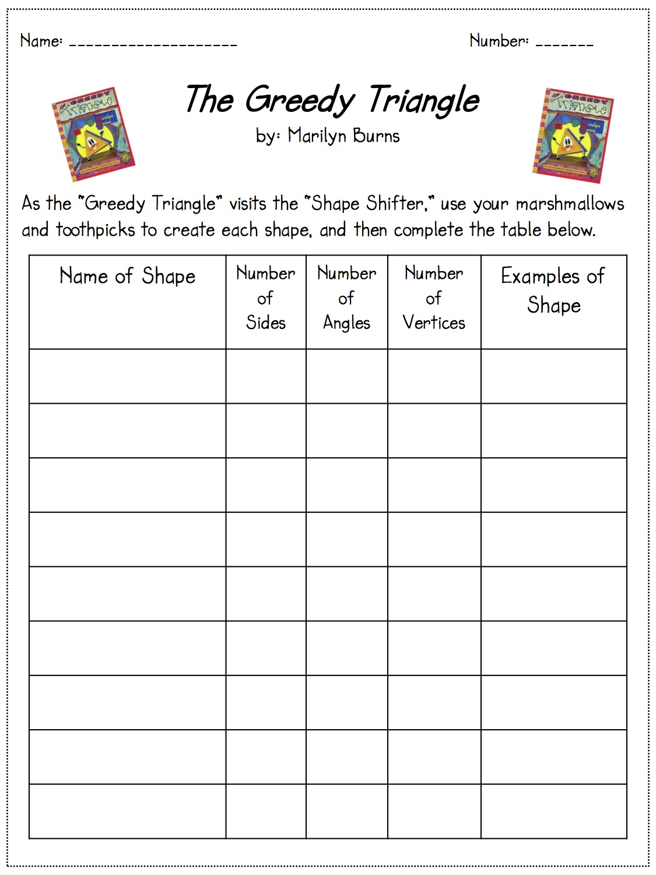
Share:
Students will have the opportunity to share the different shapes the triangled shape shifted into and their examples for each one. We will go through each shape’s number of sides, angles, and vertices as those should be the same.

Summarize:
Today’s lesson was a great way of showing how to transform shapes from one to another. We also were able to identify different attributes that make each shape it’s own.

Burnes, M. & Silveria, G. (1994). The Greedy Triangle. New York: Scholastic

Melvin, D. (n.d.). “The Greedy Triangle” Retrieved June 26, 2017 from www.teacherspayteachers.com

Quadrilateral Sort
MN State Standard | Materials
2.3.1.2 Identify the name of basic two- and three- dimensional shapes, such as squares, circles, triangles, rectangles, trapezoids, hexagons, cubes, rectangular prisms, cones, cylinders, and spheres. | *Shape sheet for each group  *Scissors  *Math Journal or other recording sheet for students  *Chart paper & markers
Objective: The students will sort the quadrilaterals based on attributes.

Launch: What do we know about quadrilaterals? Today we are going to do a sort of only quadrilaterals. We are going to explore to see if we can tell which ones should belong to the same groups.

Explore: Students work in groups to cut out the shapes and sort them into groups that make sense to them. Then discuss how they will share their sort with the class.

Share: As a class listen and talk about how each group sorted their shapes. Is there a way we can start to write a rule for each group?

Summarize: Quadrilaterals are sorted based on their sides and angles. We have done a good job of coming up with a rule for each group.

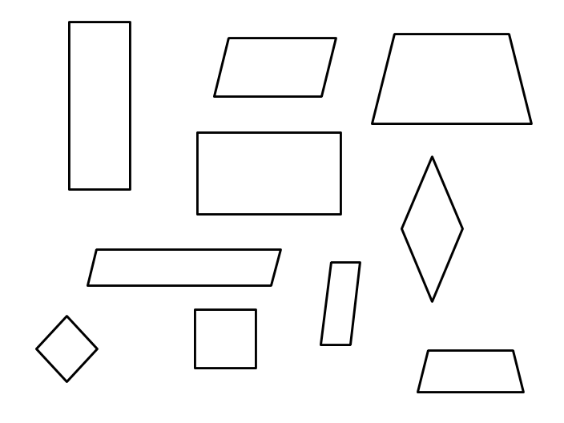

Quadrilateral Search

MN State Standard | Materials
2.3.1.2 Identify the name of basic two- and three- dimensional shapes, such as squares, circles, triangles, rectangles, trapezoids, hexagons, cubes, rectangular prisms, cones, cylinders, and spheres. | *Plain drawing paper for each student  *Ruler or straightedge  *Pencils and crayons  *Chart paper and markers for anchor chart
Objective: The students will identify different quadrilateral shapes with in a drawing and color them.
Launch: Today we are going to be creative mathematicians. We are going to create MATH ART. What is a quadrilateral? What can they look like?

Explore: Students use a straightedge to create an abstract design by criss crossing lines on their paper. Once they have a design created, they should use crayons to only color in the spaces that have 4 sides. This should create a colorful work of many different quadrilaterals.

Share: Students show the class their work and describe the quadrilaterals that they made and found in their project. As a class record the different types of quadrilaterals that were discovered.
Summarize: There are many different types of quadrilaterals that we have made using our straightedge. We also were able to describe and compare them using their sides and angles.

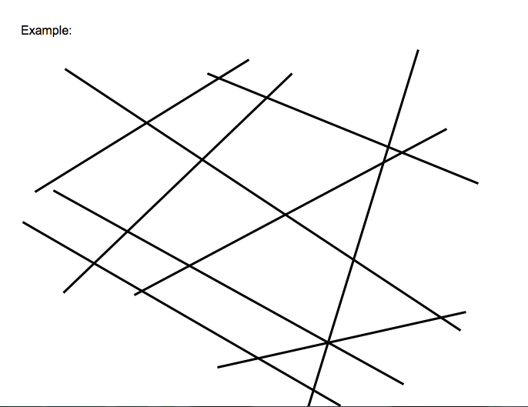

Scoot: Parallel and Perpendicular Lines

Standard:
3.3.1.1 Identify parallel and perpendicular lines in various contexts, and use them to describe and create geometric shapes, such as right triangles, rectangles, parallelograms and trapezoids.

Objective:
Students will identify parallel and perpendicular lines created by each other as well as any right triangles, rectangles, or other polygons they might see.
Materials:
- washi tape (or masking, any tape that is easily visible)
- desks

Launch:
Start putting seemingly random lines of tape on the board (make sure at least two are parallel and two are perpendicular and make a polygon within them). As students start to wonder what you are doing and maybe asking questions about it. Ask them if they notice anything about the lines of tape on the board (students have previously been taught what parallel and perpendicular lines are). Prompt the students to tell you that there are parallel and perpendicular lines. Hopefully they can maybe find a polygon in the lines as well. If not, guide them to find it by asking if they can see a polygon within the lines. Explain that today they will all have a chance to make some tape lines of their own on their desks. Ask students if they remember how to play “Scoot” (students have previously played a variation of this game).

Explore:
Review the rules again about how to switch seats when the teacher says “Scoot!” Explain that in this version students will identify any parallel or perpendicular lines or any polygons that they see in another student’s tape lines. They will do this by using a dry erase marker to mark the parallel and perpendicular lines with corresponding numbers. Any polygons that are found will be marked by drawing it within the lines. Show examples with the tape lines on the board. Give students time to make their tape lines on their desks. When time is up and you are ready to start the game “Scoot”, have students just finish sticking their last piece of tape on their desk and get ready to start. Say “Scoot!” to start the game and give students a chance to get to the next desk. Remind students to take their dry erase marker with them. Keep playing a few rounds so that students get a chance to look at several different sets of lines.

Share:
After students have had a chance to see several sets of lines, ask students to go back to their desk and look at what others had found and marked in their lines. Look around at desks and purposely pick a desk that has a mistake on it. Ask students to gather around it the best they can and ask what students see. What lines have been identified as parallel, perpendicular, and are there any polygons drawn in? Are they all correct? Why or why not? Go to another desk and ask the same questions. Have a few students share which sets of lines they thought were easier or harder for them to identify.

Summarize:
Explain the difference between parallel and perpendicular lines again and discuss where you might see these in the real world with the class. Have them point out some examples around the classroom. Tell students that they will continue to find examples of these in the next few days.

Assess/Analyze:
Give students this exit slip:

Circle the parallel lines, draw a square around the perpendicular lines, and draw a heart around the right triangle.

3-D Shape Hunt
MN State Standard | Materials
2.3.1.2 Identify the name of basic two- and three- dimensional shapes, such as squares, circles, triangles, rectangles, trapezoids, hexagons, cubes, rectangular prisms, cones, cylinders, and spheres. | *3-D Shapes to show as examples  *Math journal  *Recording chart paper
Objective: Students will use the 3-D shapes as models to identify things in the school building that are the shape.

Launch: We are going to go on a shape hunt! Your job is to find as many things in our school that are the 3-D shape that your group is hunting for. Show the models of the shapes and identify the faces and edges. Talk about the characteristics of each shape.

Explore: Each group should have a model or block of a 3-D shape. Cubes, rectangular prisms, and spheres. The students work as a group to walk around the building and identify objects that fit into their shape group.

Share: Groups come back to the room and share what they found. How did you identify which shape things were. Did you use your models to help you? Did you find objects that were made up of 2 or more shapes?

Summarize: Shapes are everywhere! We can fine them by looking at the faces and edges of things in our world. Look around your house tonight and see if you can find the different 3-D shapes.

